Antonio Scalfaro

CMSC 451

05/23/2024

**Homework 2**

1) Prove

=

= now reduce common factor n = $\lim_{n→∞}{\frac{18n+8}{10}}$

This shows as the limit approaches infinity the value approaches infinity, therefor f(n) grows faster than g(n), $f ∈ Ω\left(g\right)$.

Prove $g ∈ θ\left(f\right):$

$\lim_{n→∞}{\frac{g(n)}{f(n)}}$ = $\lim_{n→∞}{\frac{{5n}^{2}+9}{{6n}^{3}+ {4n}^{2}+2}}$

= $\lim_{n→∞}{\frac{10n}{{18n}^{2}+ {8n}^{}}}$ now reduce common factor n = $\lim_{n→∞}{\frac{10}{18n+8}}$

This shows as the limit approachs infinity the value approaches 0, therefor g(n) grows slower than f(n),

2) 2

3

4n + 10

3n

2n2 + 10n + 5 n2 + 6n

2n3 + n2 + 6

2n

4n

3) 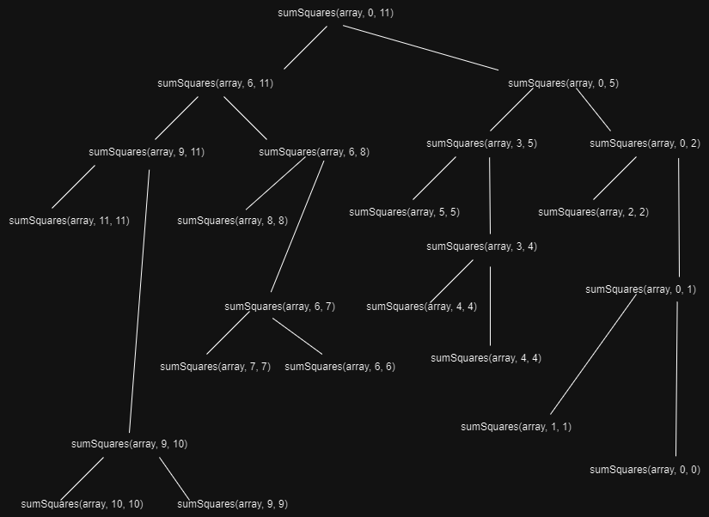

Height of the tree is given by $h\left(n\right)= \log_{2}{n}$

Sum of the nodes can be expressed as a summation: $t\left(n\right)= \sum_{k=0}^{\log_{2}{n}}{2^{k}}$ = $2^{\log_{2}{n}+1}-1$ = 2n – 1

Big $θ$ for memory is $θ(logn)$

Execution time for t(n) = $θ(n)$

Iterative solution: int sumSquare(int[] array)

Int sum = 0

For ( i = 0 to array length)

Sum += array[i] * array[i]

Return sum

Execution time for iterative approach, t(n) = $θ(n)$

Big $θ$ for Memory is $θ(1)$

Though both approaches have the same execution time, the iterative approach uses less memory and is therefor better than the recursive approach.

4) The recurrence equation looks as follows: t(n) = $t\left(\left\lceil \frac{n}{2}\right\rceil \right)+t\left(\left\lfloor \frac{n}{2}\right\rfloor \right)+1=2t\left(\frac{n}{2}\right)+1$

Initial condition: t(1) = 1

The recurrence tree work will be: Root level = t(n)

Level 2 = 2 * t($\frac{n}{2})$

Level 3 = 4 $t(\frac{n}{4})$

*

Level $\log_{2}{n}$ = n * t(1)

The critical exponent will be: $E= \frac{lg b}{\lg{c}}$ where the branching factor, b, is 2 and the cutting factor, c, is 2. Therefor $E= \frac{\lg{2}}{\lg{2}}=1$

Using part 1 of the Little Master’s Theorem t(n) $∈ θ\left(n^{E}\right)= θ(n)$

Because this is a sum of squares problem, each element must be visited at least one time, which makes a $θ(n)$ execution time to be optimal.